# Major Project Report

JARVIS – AI AUTOMATED VIRTUAL ASSISTANT

***Submitted in partial fulfilment of the requirement for the award of the degree of***

***B. Tech in Computer Science & Engineering from***

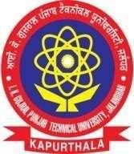

# IKG Punjab Technical University, JALANDHAR

**Submitted by: Guided by:**

Ankush (1908740) Mr. Vinay Badyal Mukund Jee Tiwari (1908748)



Department of Computer Science & Engineering

SRI SUKHMANI INSTITUTE ENGINEERING &TECHNOLOGY

DERA BASSI, 140057